|  |  |
| --- | --- |
| C # PROGRAMS BY LOKESH.NADELLA | DAY 4 ASSIGNMENT |

**1. write a multliplication table on a c# program**

**Code:**

namespace day4_muplitication_c

{

internal class Program

{

static void Main(string[] args)

{

int input, i;

Console.WriteLine("enter any number:");

input = Convert.ToInt32(Console.ReadLine());

for (i = 1; i <= 10; i++)

Console.WriteLine(input + "*" + i + "=" + input * i);

Console.ReadLine();

}

}

}

Output:

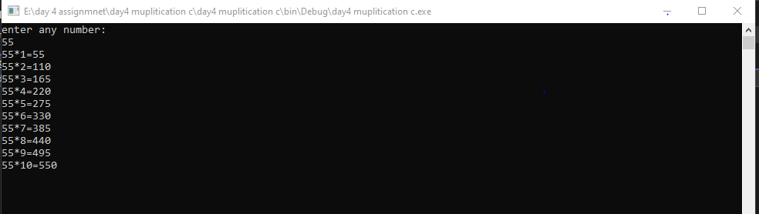

**2.PRINT FACTORIAL NUMBER OF A GIVEN NUMBER IN C# PROGRAM**

namespace day_4_factorial

{

internal class Program

{

static void Main(string[] args)

{

int input, i,fact = 1;

Console.WriteLine("enter any number :");

input = Convert.ToInt32(Console.ReadLine());

for (i = 1; i <= input; i++) ;

fact = fact * i;

Console.WriteLine("factorial of a number :" + fact);

Console.ReadLine();

}

}

}

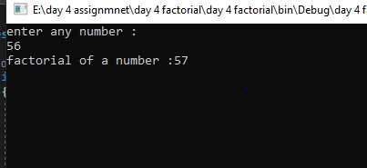

**3 write a c# program of sum of n natural numbers**

namespace DAY4_sum_of_n_natural_number

{

internal class Program

{

static void Main(string[] args)

{

int input, i, sum = 0;

Console.WriteLine("enter any number :");

input = Convert.ToInt32(Console.ReadLine());

for (i = 0; i <= input; i++)

sum = sum + i;

Console.WriteLine("sum of given natural number is :" + sum);

Console.ReadLine();

}

}

}

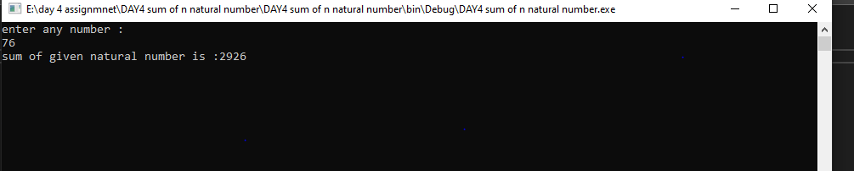

**4. Print factors of a given number in c# program**

using System;

using System.Collections.Generic;

using System.Linq;

using System.Text;

using System.Threading.Tasks;

namespace day4_factors_of_number

{

internal class Program

{

static void Main(string[] args)

{

int input, i;

Console.WriteLine("enter any number :");

input = Convert.ToInt32(Console.ReadLine());

for (i = 1; i <= input; i++)

{

if (input % i == 0)

Console.WriteLine(i);

}

Console.ReadLine();

}

}

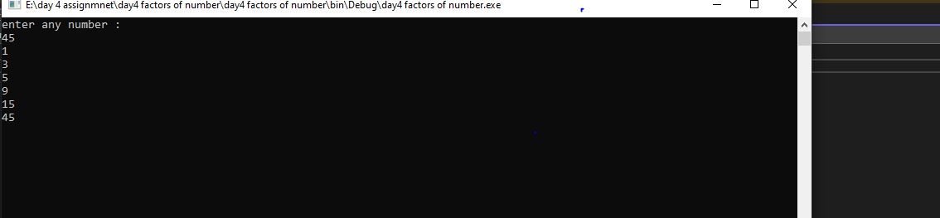

5.WRITE A C# PROGRAM ON FINDING A POWER B ?

using System;

using System.Collections.Generic;

using System.Linq;

using System.Text;

using System.Threading.Tasks;

namespace day_4_power_of_number

{

internal class Program

{

static void Main(string[] args)

{

int a, b, result = 1, i;

Console.WriteLine("enter value of a:");

a = Convert.ToInt32(Console.ReadLine());

Console.WriteLine("enter value of b:");

b = Convert.ToInt32(Console.ReadLine());

for (i = 1; i <= b; i++)

result = result * a;

Console.WriteLine("the power is:" + result);

Console.ReadLine();

}

}

}

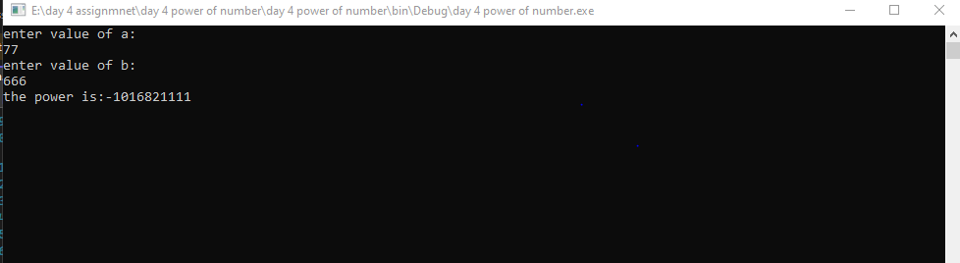

**6.write a c# program to check whether the number is prime or no**

using System;

using System.Collections.Generic;

using System.Linq;

using System.Text;

using System.Threading.Tasks;

namespace Day_4_Multiplication_prgm_1

{

internal class Program

{

static void Main(string[] args)

{

int input, i, count= 0;

Console.WriteLine("Enter any number:");

input = Convert.ToInt32(Console.ReadLine());

for (i = 1; i <=input; i++)

{

if(input%i==0)

count++;

}

if (count == 2)

Console.WriteLine("It is a prime number", input);

else Console.WriteLine("It is not a prime number", input);

Console.ReadLine();

}

}

}

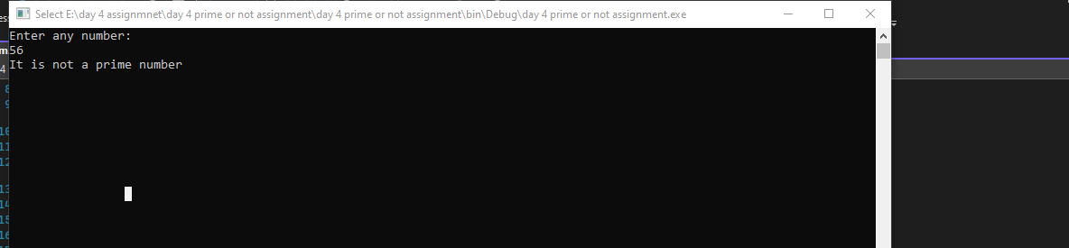

**7. WRITE A C# PROGRAM TO CHECK WHETHER THE NUMBER IS PRIME OR NOT BY USING FUNCTION.**

internal class Program

{

static void Main(string[] args)

{

Console.WriteLine("Enter any number:");

int input = Convert.ToInt32(Console.ReadLine());

if (isPrimeNumber(input))

Console.WriteLine("It is a PrimeNumber", input);

else

Console.WriteLine("It is not a PrimeNumber", input);

Console.ReadLine();

}

static bool isPrimeNumber(int input)

{

for (int i = 2; i < input; i++)

{

if (input % i == 0)

{

return false;

}

}

return true;

}

}

}

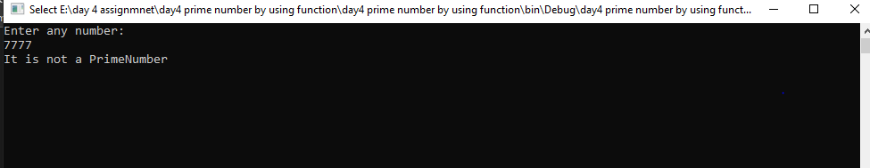

8. WRITE A C# PROGRAM TO FIND FACORIAL OF A NUMBER USING RECURSION

Using System;

using System.Collections.Generic;

using System.Linq;

using System.Text;

using System.Threading.Tasks;

namespace DAY4__factorial_of_a_number_using_recursion

{

internal class Program

{

static void Main(string[] args)

{

Console.WriteLine("Enter any number:");

int input = Convert.ToInt32(Console.ReadLine());

int factorial = getFact(input);

Console.WriteLine("factorial value is: " + factorial);

Console.ReadLine();

}

static int getFact(int input)

{

if (input == 0)

return 1;

else

return input * getFact(input - 1);

}

}

}

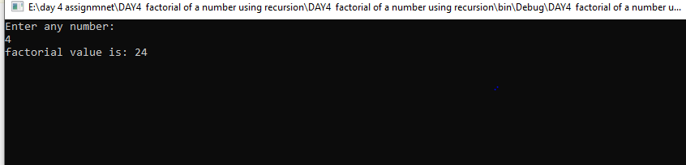

**9.WRITE A C# PROGRAM TO PRINT PRIME NUMBERS IN GIVEN RANGE**

namespace day4_prime_numbers_in_given_range

{

internal class Program

{

static void Main(string[] args)

{

Console.WriteLine("Enter number 1:");

int input1 = Convert.ToInt32(Console.ReadLine());

Console.WriteLine("Enter number 2:");

int input2 = Convert.ToInt32(Console.ReadLine());

for (int i = input1; i <= input2; i++)

{

isPrime(i);

}

Console.ReadLine();

}

static void isPrime(int input)

{

bool isPrimenum = true;

for (int i = 2; i < input; i++)

{

if (input % i == 0)

{

isPrimenum = false;

}

}

if (isPrimenum == true)

{

Console.WriteLine(input);

}

}

}

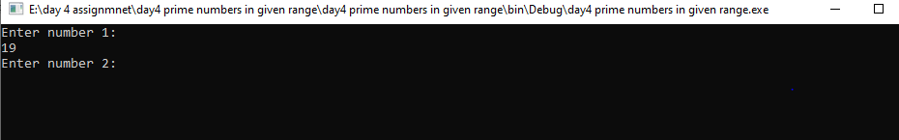

**10. WRITE A C# PROOGRAM TO PRINT FIBANOCCI SERIES?**

static void Main(string[] args)

{

int a = 0, b = 1, c, n;

Console.WriteLine("Enter number of fibnocci range n-2:");

n = Convert.ToInt32(Console.ReadLine());

Console.WriteLine("0");

Console.WriteLine("1");

for (int i = 0; i < n - 2; i++)

{

c = a + b;

a = b;

b = c;

Console.WriteLine(c);

}

Console.ReadLine();

}

}

}

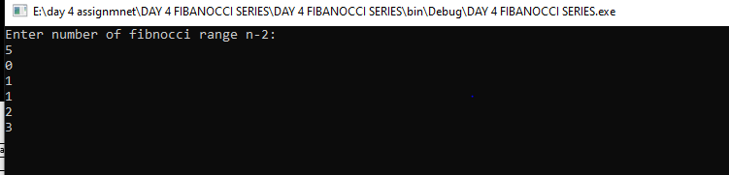

**11. WRITE A C# ON ARMSTRONG NUMBER?**

internal class Program

{

static void Main(string[] args)

{

int n, rem, m, res = 0;

Console.WriteLine("Enter any number :");

n = Convert.ToInt32(Console.ReadLine());

m = n;

while (m > 0)

rem = m % 10;

m /= 10;

res = res + rem * rem * rem;

}

Console.WriteLine((res == n) ? "Armstrong" : "not");

Console.ReadLine();

}

}

}

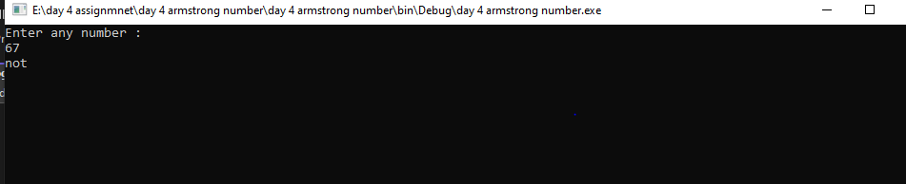

**12. WRITE A C# PROGRAM TO FIND THE NUMBER IS ARMSTRONG OR NOT USING FUNCTION?**

namespace day_4_armstrong_number_by_function

{

internal class Program

{

static void Main(string[] args)

{

int n, rem, m, res = 0;

Console.WriteLine("Enter any number :");

n = Convert.ToInt32(Console.ReadLine());

getArmtrong(n);

Console.ReadLine();

}

static void getArmtrong(int n)

{

int rem, m, res = 0;

m = n;

while (m > 0)

{

rem = m % 10;

m /= 10;

res = res + rem * rem * rem;

}

Console.WriteLine((res == n) ? "Armstrong" : "not Armstrong");

}

}

}

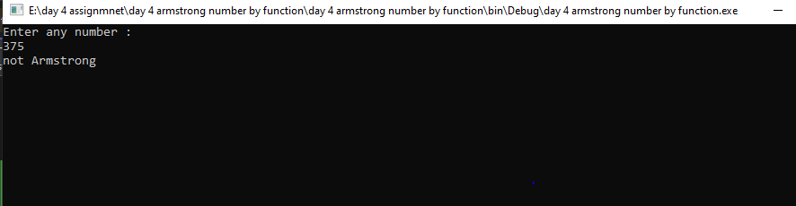

**13. WRITE A C# PROGRAM TO SWAP TWO NUMBERS USING THIRD VARIABLE**

namespace day_4_swapping_two_numbers_with_third_variable

{

internal class Program

{

static void Main(string[] args)

{

int a = 5, b = 3, temp;

temp = a;

a = b;

b = temp;

Console.WriteLine("Values after swapping are:");

Console.WriteLine("a=" + a);

Console.WriteLine("b=" + b);

}

}

}

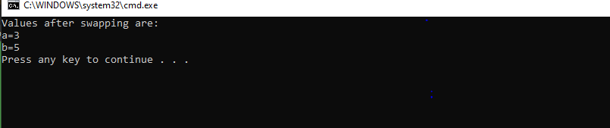

**14. SWAPPING TWO VARIABLES WITHOUT VARIABLE**

namespace DAY_4_assignment_swapping_without_variable

{

internal class Program

{

static void Main(string[] args)

{

int a = 10, b = 20;

a = a + b;

b = a - b;

a = a - b;

Console.WriteLine("Values after swapping are:");

Console.WriteLine("a=" + a);

Console.WriteLine("b=" + b);

}

}

}

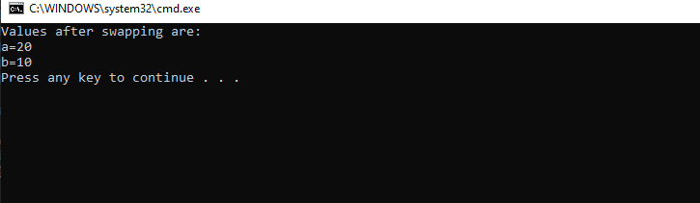

**15. Write a c# program on palindrome?**

using System;

using System.Collections.Generic;

using System.Linq;

using System.Text;

using System.Threading.Tasks;

namespace day_4_assignmnent_on_palindrome

{

internal class Program

{

static void Main(string[] args)

{

int n, m, rem, rev = 0;

Console.WriteLine("Enter a number");

n = Convert.ToInt32(Console.ReadLine());

m = n;

while (m > 0)

{

rem = m % 10;

m = m / 10;

rev = rev * 10 + rem;

}

if (n == rev)

Console.WriteLine("Given numbr is palindrome");

else

Console.WriteLine("Given numbr is not a palindrome");

Console.ReadLine();

}

}

}

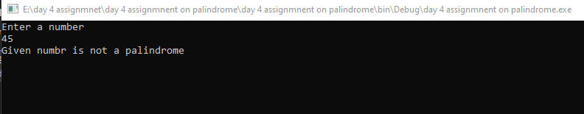

**16. WRITE A C# PROGRAM ON REVERSING NUMBER?**

int n,m,rem,rev=0;

Console.WriteLine("Enter a number");

n= Convert.ToInt32(Console.ReadLine());

m = n;

while(m>0)

{

rem = m % 10;

m= m / 10;

rev = rev * 10 + rem;

}

Console.WriteLine("The Reverse Number is: " +rev);

Console.ReadLine();

}

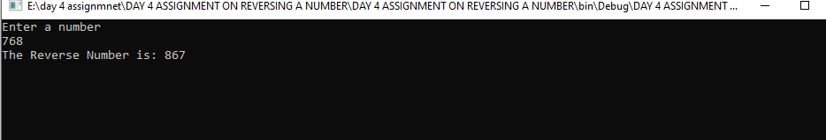

**17. WRITE A C# PROGRAM ON SUM OF DIDGITS?**

using System;

using System.Collections.Generic;

using System.Linq;

using System.Text;

using System.Threading.Tasks;

namespace day_4_assignment_on_sum

{

internal class Program

{

static void Main(string[] args)

{

int n, m, rem, rev = 0;

Console.WriteLine("Enter a number");

n = Convert.ToInt32(Console.ReadLine());

m = n;

while (m > 0)

{

rem = m % 10;

m = m / 10;

rev = rev + rem;

}

Console.WriteLine("The Sum of Numbers is: " + rev);

Console.ReadLine();

}

}

}

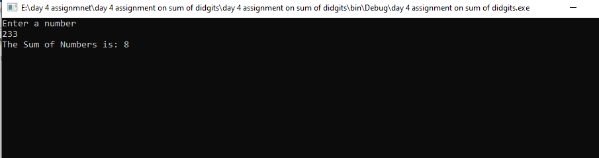

**18. WRITE A C# PROGRAM FOR FACTORIAL OF A GIVEN NUMBER USING FUNCTION?**

using System;

using System.Collections.Generic;

using System.Linq;

using System.Text;

using System.Threading.Tasks;

namespace day_4_assignment_on_facorial_using_function

{

internal class Program

{

static void Main(string[] args)

{

int input, i, fact = 1;

Console.WriteLine("Enter any number:");

input = Convert.ToInt32(Console.ReadLine());

getFact(input);

}

static void getFact(int input)

{

int fact = 1;

for (int i = 1; i <= input; i++)

{

fact = fact * i;

}

Console.WriteLine("factorial of a given number:" + fact);

Console.ReadLine();

}

}

}

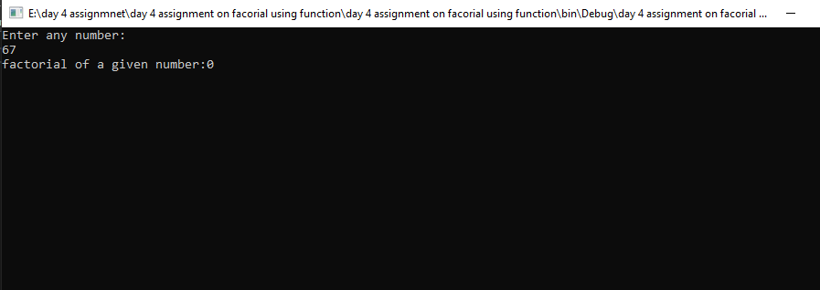

**19. WRITE A C# PROGRAM ON ARMSTRONG NUMBER IN GIVEN RANGE?**

}

}

Console.ReadLine();

}

static bool getArmtrong(int n)

{

int rem, m, res = 0;

m = n;

while (m > 0)

{

rem = m % 10;

m /= 10;

res = res + rem * rem * rem;

}

return ((res == n) ? true : false);

}

}

}

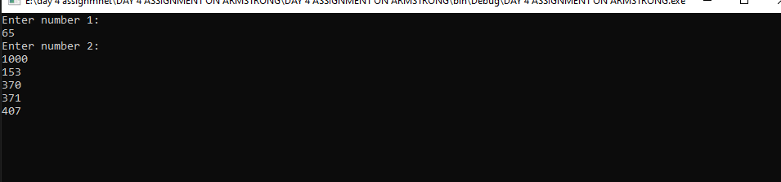

**20. WRITE A C# PROGRAM TO PRINT STARS IN PATTERN**

using System;

using System.Collections.Generic;

using System.Linq;

using System.Text;

using System.Threading.Tasks;

namespace DAY_4_ASSIGNMENT_ON_STARS

{

internal class Program

{

static void Main(string[] args)

{

Console.WriteLine("Enter no.of rows to be Printed:");

int n = Convert.ToInt32(Console.ReadLine());

for (int i = 1; i <= n; i++)

{

for (int j = 1; j <= i; j++)

{

Console.Write(" * ");

}

Console.WriteLine();

}

Console.ReadLine();

}

}

}

